Jacek Bartosiak, PhD
CEO and Founder of Strategy & Future

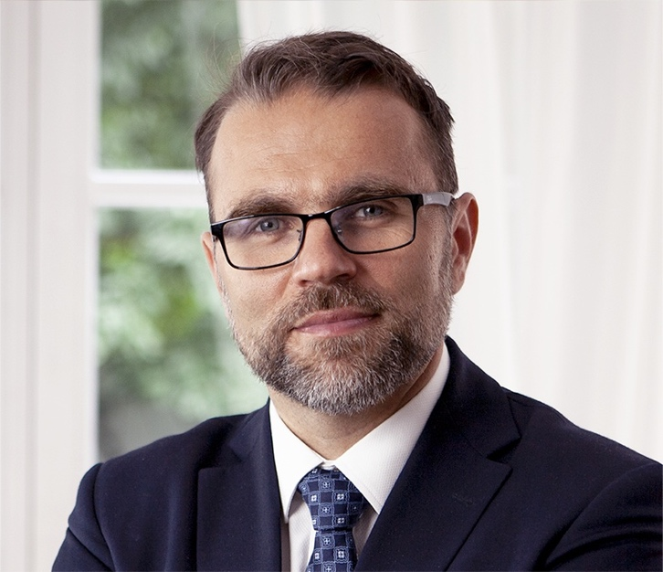
Jacek Bartosiak is the is founder and owner of Strategy & Future. He is also an expert in geopolitics and geostrategy and a senior analyst with Geopolitical Futures. Dr. Bartosiak is the author of three books: Pacific and Eurasia: About the War (2016), dealing with the upcoming rivalry of great powers in Eurasia and about the potential war in the western Pacific; The Commonwealth Between Land and Sea: On War and Peace (2018), on the geostrategic situation of Poland and Europe in the era of rivalry between powers in Eurasia; and The Past Is a Prologue on Geopolitical Changes in the Modern World. In addition, he is the Director of the War Games and Simulation Program of the Pulaski Foundation; a Senior Fellow at The Potomac Foundation in Washington; co-founder of "Play of Battle," which prepares military simulations; an associate of the New Confederation and the New Generation Warfare Center in Washington; a member of the advisory team of the Government Plenipotentiary for Central Communication Port (2017-2018); and president of the board of the company, Centralny Port Komunikacyjny Sp. z o. o. (2018–2019). Dr. Bartosiak speaks at conferences on the strategic situation in Central and Eastern Europe, the Western Pacific, and Asia. He graduated from the Faculty of Law and Administration at the University of Warsaw and is a managing partner at a law firm dealing with business services since 2004.

